Name: Shailja kant Tiwari

Course:B.Sc(H)Physics,Sem5

Roll No.-081

SOURCE CODE:

clear;clf;

b=input("Enter b:")

function **dx**=f(**r**, **x**, **E**, **b**)

m=940; h=197.3;

V=(100*(**r**^2))/2+(**b**\*(**r**^3))/3

**dx**(1)=**x**(2)

**dx**(2)=((2*m)/(h*h))*(V-**E**)\***x**(1)

endfunction

E1=input("Enter guess 1 for energy(eV):");

E2=input("Enter guess 2 for energy(eV):");

tol=abs(E1-E2)

while tol>0.000001

tol=abs(E1-E2)

r=0:0.01:4

u1=ode([0;1],0,r,list(f,E1,b));

u2=ode([0;1],0,r,list(f,E2,b));

E3=(E1+E2)/2

u3=ode([0;1],0,r,list(f,E3,b));

if(u1(1,400)*u3(1,400))<0 then

E2=E3

else

E1=E3

end

end

disp(E3,"The energy eigen value (eV) for b="+string(b)+"is:" )

plot(r,u3(1,:));

xlabel('r',"fontsize",4);ylabel('u(r)',"fontsize",4)

title("Curve for Schrodinger equation with anharmonic oscillator potential")

OUTPUT:

Enter b:0

Enter guess 1 for energy(eV):90

Enter guess 2 for energy(eV):110

The energy eigen value (eV) for b=0is:

96.528248

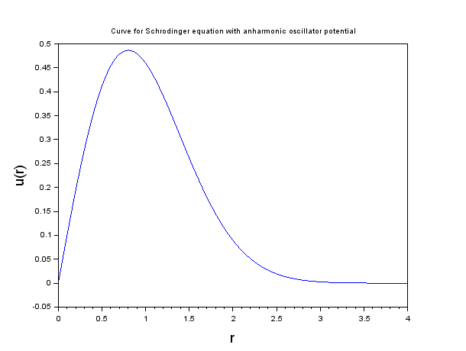

Enter b:10

Enter guess 1 for energy(eV):90

Enter guess 2 for energy(eV):110

The energy eigen value (eV) for b=10is:

100.24661

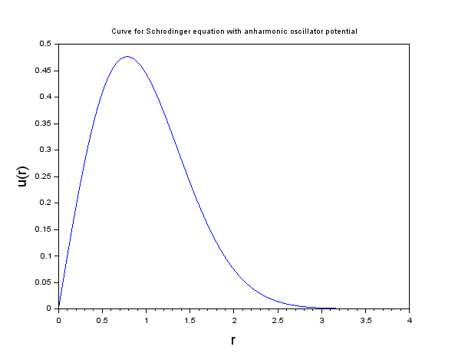

Enter b:30

Enter guess 1 for energy(eV):90

Enter guess 2 for energy(eV):110

The energy eigen value (eV) for b=30is:

106.89604

